Comprehensive Art- Yearlong Curriculum (Unit Plans)
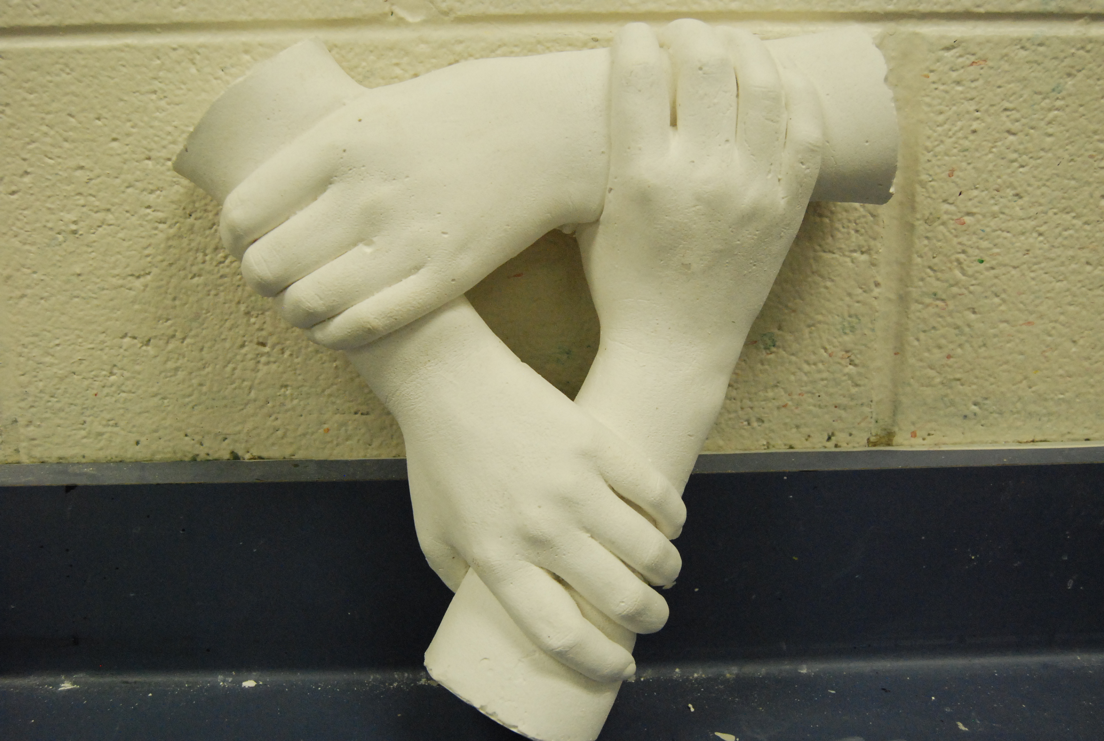

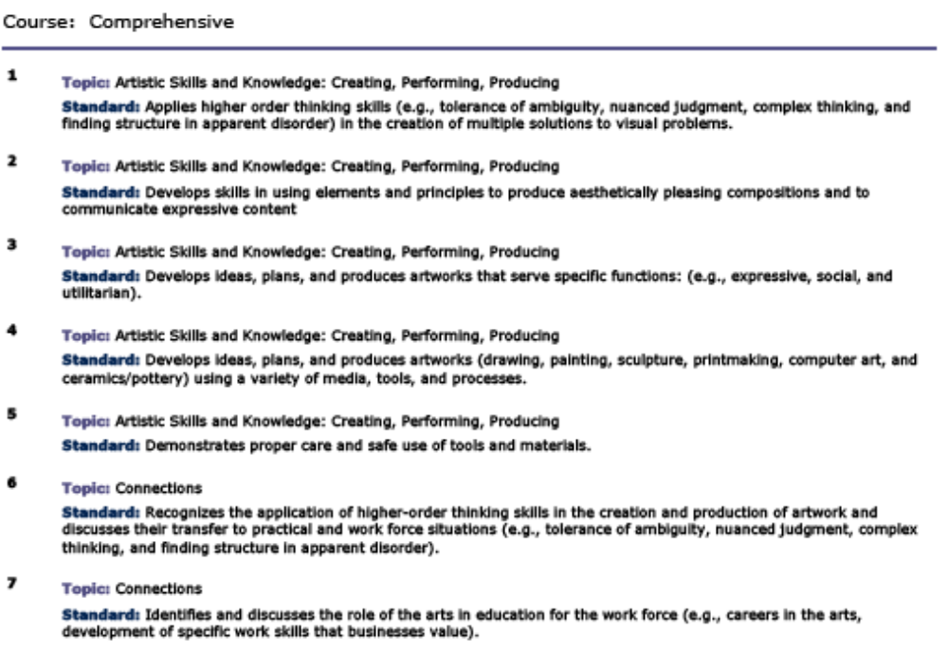
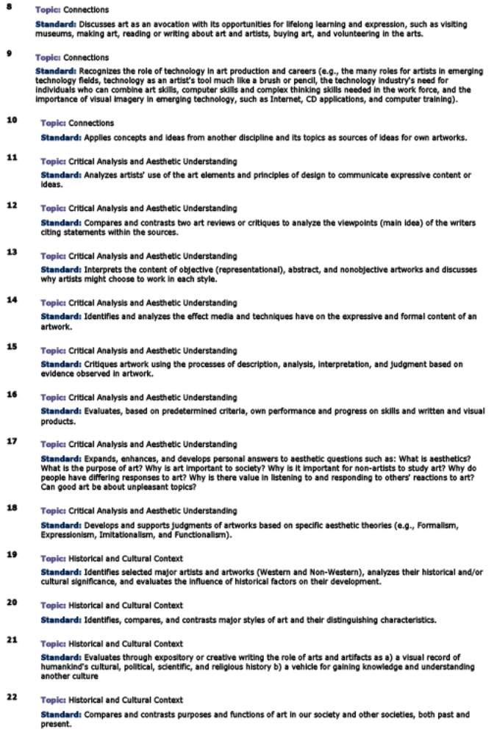

FIRST SEMESTER

A. What is Art- Symbolism in Art (2 weeks)

Objective: Developing critical thinking skills to help students come up with symbols for the 20 most important things in their life.

Objective: Learning the 3 basic pencil drawing techniques; developing values; practices and applications.

* What is Art Discussion- Students are introduced to a variety of different artists and the messages they convey in their art.
*Students develop a list of the 20 most important things in their life, and collectively come up with symbols to represent each of their elements.

B. INTRODUCTION TO DESIGN (2 weeks)

Objective: Practices in basic art foundations; design principles and elements; art terminology; interpreting in multi-media.

* Line---Development of an idea to be expressed with various line forms, thickness and movements; contour study of precise line placement; creation of a simple composition which demonstrates an arrangement of overlapping, moving, opaque or transparent shapes using collage materials. Design enhanced with texture. See: Line Foundations
* Texture---Visual representation of surface textures; imaginative linear designs of created texturals for enhancement of specific areas and details. See: Texture 2
* Shape---Naturalistic, free form, geometric, and abstract variations;creation of a simple composition with overlapping, opaque or transparent shapes composed of collage materials; texture enhancement. See: Many Shape Varieties
* Repetition---shape duplication in the design area; realistic or abstract forms. See: Introduction
* Positive/Negative Design---Creating new, inventive shapes by single, double and triple cutting a large curved, angular or combination lines on an axis. Free, creative design contrasting preplanned ideas and constructions. *Major project.

C. Proportions: Self-Portraits (2 weeks)

Enduring Understanding(s):
Students will understand that …
- Proportion is a principle of art that describes the size, location or amount of one element to another (or to the whole) in a work. It has a great deal to do with the overall hamrony of an individual piece.
Essential Question(s):
What is proportion?
Students will know: using proportion you can create an accurate self-portrait of yourself that is four times larger then your actual face.
Students will be able to:
- Use a ruler to measure the features of the face
- Accurately quadruple the size of the face in a realistic self-portrait.
- Correctly identify by sight correct and incorrect facial proportions.
Performance Tasks for Assessment:
Origional Self-portrait sketch
Self-portrait: step by step process.
Daily feature sketches.
Assessment for learning & Assessment of learning
Other Evidence:
Writing Assignments Across the Curriculum once a week
Teacher Observation
Daily corresponding sketches
Key Vocabulary:
Grid, scale, proportion, perspective,
If Learning Does Not Occur:
Reteach, redirect, Reassessment (for and of Learning)
Personal demonstrations, Simplified steps to increase student achievement.

D. PAINTING: COLOR STUDY (4 weeks)
Objective: How we see color; differences between light and pigment; color classifications and tempera mixtures and applications.
* Primary hues---Used to mix seconday, intermediate, complementary and analogous mixes. See: Color
* Tints---Raising intensity of a hue by adding white. See: Tints
* Shades---Lowering intensity by adding black. See: Shades
* Neutral Hues---Skill practice with hues + theirs complement; selection of one for final blends. See: Complements and Evaluations
* Grid design.---Development of a repeat pattern into a large grid of 6 areas--each illustrating one of the color systems. See: Tempera Apps
* Painting skill practices.---Brush variations and wooden stick texture painting; broad stroke, pointillism, color blending. See: Basics
* Class Practice---Correct order of painting, painting over a sketch; high to low values. See: Practice
* Summary Design.---A large painting to show competence with 3 different painting techniques, color values and surface textures; correct order of painting. Summary Designs

E. GRID DRAWING (2 weeks)

Objective: Precise drawing with grid enlargement; creating a drawing with surrealistic principles.

* Pictorial resources---Used to create a colorful collage showing unusual color, unreal combinations, fantasy arrangement with 5-6 images. Application of a small grid over the collage. See: Introduction and Evaluations
* Design is enlarged---With a 2" grid outlined in ball point pen. See above.
* Transfer---To final format. Colored pencil rendering; tonal values, textures and accuracy of proportional enlargement stressed. See: Applications

F. CHARCOAL DRAWING (1 weeks)
Objective: Learning value control with 2 different charcoal types; light and dark values with a new media; development of drawing skills.

* Skill practice---Showing 4 values of each charcoal type and 4 values blended together. See: Charcoal
* Skill practice---Drawing a large rectangular object in perspective as a solid, closed, open, and overlapped form. Applying valued to the shapes. See: Rectangles
* Skill practices---Drawing and rendering cylinder forms-open, closed, opaque and transparent; compilation of all practices. See: Cylinders
* Skill practice---Using photo resources. Rendering shadows, reflections, ellipses, overlapping and transparent shape composition.
* Summary design---Large drawing based on a theme demonstrating the practiced experiences. See: Summary Design

G. PASTELS AND COLOR, WET TECHNIQUE (2 weeks)

Objective: Applying values with a different media; basic color blends; setting pastels with water.

* Skill practice--- color mixing and blending exercises; wet and dry methods. See: Introduction
* Shapes and Values--- adding color in layers. See: Pastel Layers
* Summary design---5 large, well balanced shapes with 3 values in each; background rendered in large washes, texture design or charcoal blends. See: Summary Design

H. WATER COLOR PAINTING (3 weeks)

Objective: Learning some basic techniques in handling a free-flowing, runny, transparent medium.

* Wash Practices---Controlling graded, flat, mixed, wet-in-wet, and wax resist in color blends. See beginning : Basics
* Comparison Studies---Warm, cool, painting in layers, and brush-style techniques. See: Contrasts
* Layer Study---Wet and dry brush applications. See: Skill 1
* Black Wash---Handling a strong neutral color. See: Skill 2
* Composition Practices---Putting it all together. See: Part 1
* Summary Design---Sketches in any art style; painting to demonstrate different techniques of water color painting. See: Apps 1
* Exam Time---Quarter Exam testing.

SECOND SEMESTER

I. LETTERING, CALLIGRAPHY AND POSTER DESIGN (4 Weeks)
Objective: learning the tools of communication arts; word, symbol, presentation, color impact and application of advertising principles.
* Font Identification---Learning the basic terminoloty of letter structure and styles; collecting and identifying 9 major letter/font styles. See: Styles
* Mechanical Spacing---Pencil skill practices with guide lines, ruler measurement and spacing of words; drawing poster letters with thickness; Roman style with serifs; italicized words. See: Mechanical Spacing (animation)
* Optical Spacing---Drawing with visual sense and good judgement. See: Optical Spacing (animation)
* Summary design---A full page of varied measured and estimated words with several letter styles and thicknesses. Assignment
* Challenge--Extra credit assignment of varied sizes and styles. Not more than 2 errors for extra credit. See: Challenge
* Calligraphy---Study of 3 basic calligraphy styles in ink and using the pen points for each; proper handling for Roman, Gothic and Script styles; word structures with case, height and width variation; See: Roman (animation)

J. SHOWCARD DESIGN (6 weeks)
Objective:Summary design in a collage assimilation of the calligraphy and writing skills practiced.
* 5 Favorites.---Layout of 5 words expressing personal favorites, each illustrating a different font style and case with lettering pens. See: Favorites
* Student Name.---Ink calligraphy of any font style/re-design in a curved arrangement. See: Names
* Invented Letters.---Selection and re-design of one letter 2 different ways in collage materials. See: New Letters
* Logo Design.---Grouping of 3 letters for a known or invented company; 3 materials to be used. See: Logos
* Creative Writing.---15-20 words lettered in Script with other fonts for word emphasis or contrast. See: Script
* Assemblage---All 5 design areas arranged as a showcard unit. See: Completed Works

K. STENCIL COLLAGE (1-3 weeks)

Objective:Positive and negative shapes become an overlapped, repetitious arrangement in a mixed media pattern design.

* Cut Shapes.---Simple, natural objects and free forms are the basis for the design. See: Stencil 1
* Transparent Design---Working with one unified hue and blending in transparent materials with open areas makes for a very interesting combination. See: Stencil 3

L. PERSPECTIVE (2-3 weeks)

Objective:---Understanding the concept of receding shapes to suggest distance; vocabulary; practices.

* One Point Perspective---Study of above, below and at eye level; right and left views; skill practices and final drawing.
* Two Point Perspective---2 sets of receding paralles; skill practices and final drawing.
* Extra Credits---Looking above or below views; creative interpretations.

M. SCULPTURE (4-8 weeks)

Objective:Sculpture in the round; learning to visualize shape continuance from side to side; vocabulary; various sculpture studies; direct, free form carving.

* Stage 1---Plaster mixing; removal from milk carton, rounding edges with fettling knives; experiencing very moist condition. See: Mixing
* Stage 2---Rough carving of shape continues; open forms an option; blocks drying out.
* Stage 3---Dry state; using rasps to define contours, create openings and grooves, and remove carving marks. Tools
* Stage 4---Finishing begun with medium grade sandpaper; rasp marks removed; continues on with finer grade until surface is as smooth as possible, no pits or cracks visible.
* Stage 5---Surface rubbed with damp muslim and then painted with milk to seal it. See: Finished Sculptures
* ICOSAHEDRON---A polygon offering many design insertions based on theme orientation. See: Polygon

N. GRAPHICS (3-4 weeks)

Objective: Cardboard blocks designed in level; crayon printing and expanding to crayon resists.

* Tagboard Block Prints---Sketches for 4 layered block shapes; cut textures, heavy fabrics and 3D materials encouraged in design; review of crayon color printing in single color, warm, cool, mixed, reversal and a large repeat design. See: Graphics Intro 2
* Mixed Media Graphics---Interval design as basic block; crayon prints made; some prints used for Crayon Resists. See: Graphics Intro 3
* Corregated Cardboard---Box sides as block print makers; cutting by levels; smooth and rippled areas. See: Level cutting
* Finishing---Multiple printing and collage amalgamation. See: Assimilation

O. STYLES IN ART (3-4 weeks)

Objective: Competence in diversified rendering of the same composition; sketches on a variety of topics; individual practices and assimilated in one format.

* Naturalistic---Show tonal blending, surface textures, 3 or more values, pencil rendering. See: Introduction (animation)
* Geometric/Abstract---Modify the shapes by splitting, exaggeration, line design, textures, new contours; markers and colored pencil rendering, collage optional. See: Abstraction
* Positive/Negative Design---Have 4 or more changeover lines and paint in 1 hue + black and white. See: Examples

